[](https://www.google.ie/url?sa=i&url=https%3A%2F%2Fsouthsideangling.ie%2Fvouchers-gift-cards%2F&psig=AOvVaw0pZSyz5xvj7CIdjrT4lGv4&ust=1589968163315000&source=images&cd=vfe&ved=0CAIQjRxqFwoTCMjPgPjTv-kCFQAAAAAdAAAAABAI)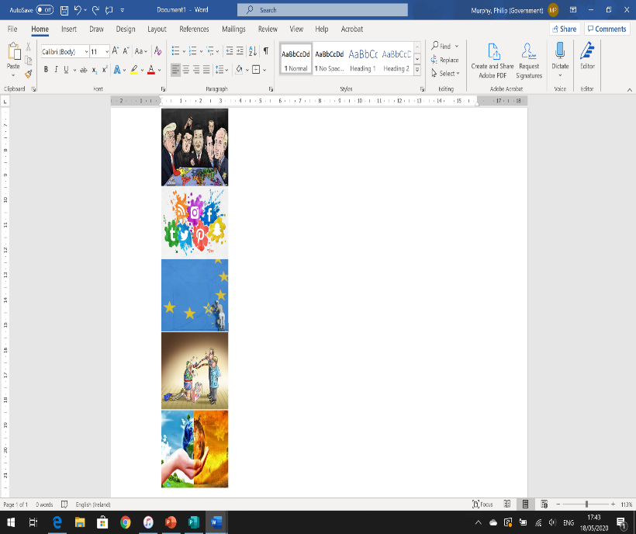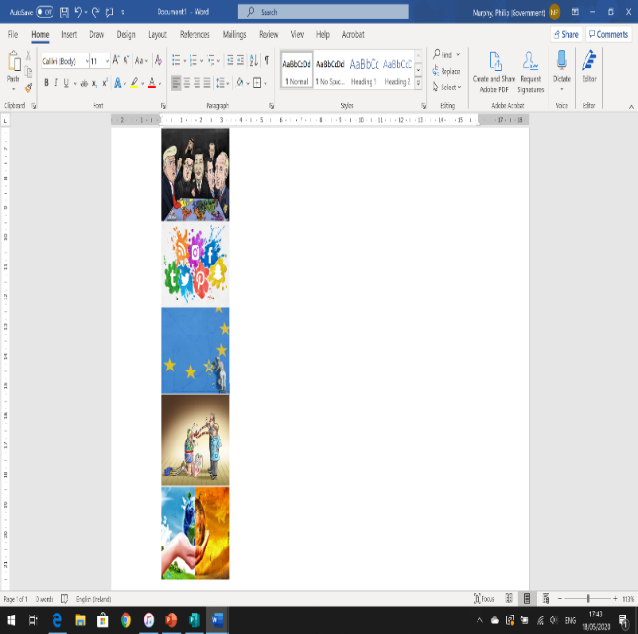[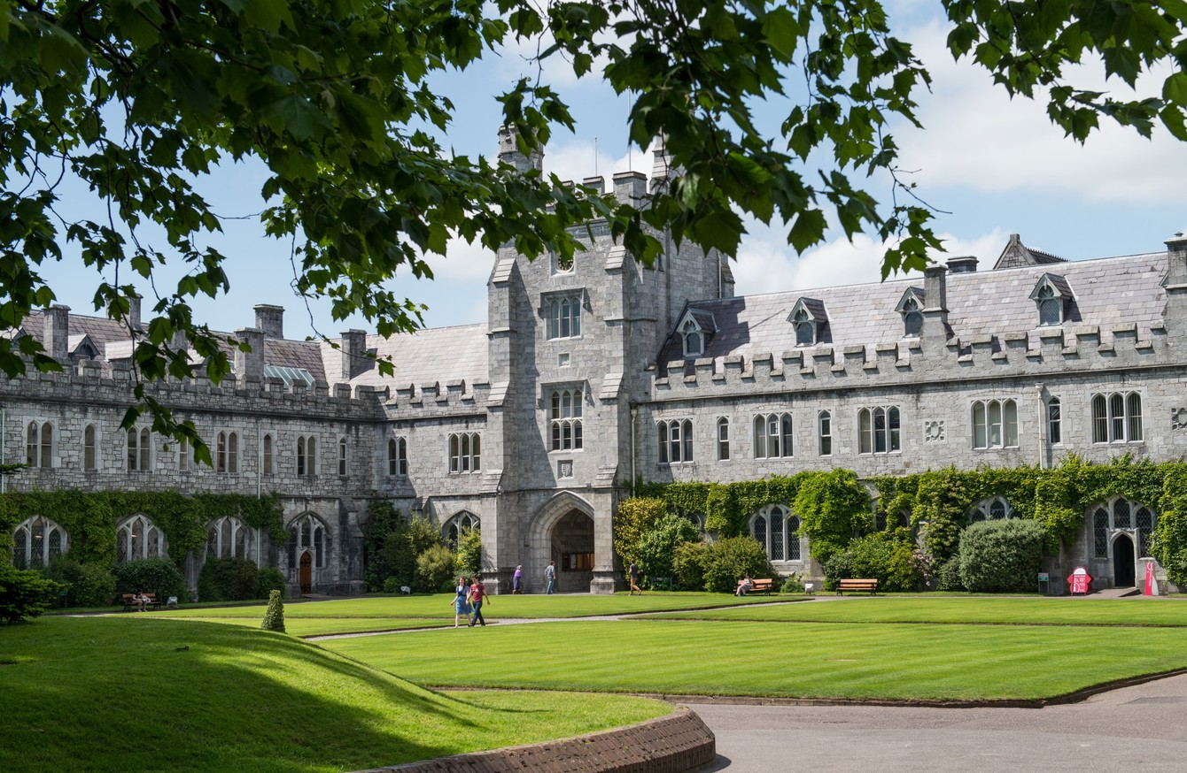](https://www.google.ie/url?sa=i&url=https%3A%2F%2Fwww.thejournal.ie%2Fucc-tcd-european-investment-bank-3099075-Nov2016%2F&psig=AOvVaw1_tIKCD2-WfSw9wY3f60d1&ust=1589907038165000&source=images&cd=vfe&ved=0CAIQjRxqFwoTCPC2j4HwvekCFQAAAAAdAAAAABAD)

**“Tell us about your *Politics & Society* Citizenship Project and be in with a chance to win €50 ”**

* Discuss your CPR topic and/or research in a 750-1,000 word essay.
* Type the essay in a MS Word or other processed document.
* Attach the document to an email which includes the following information; your name, your school’s name/address, and your P&S teacher’s name.
* Email it to philip.murphy@ucc.ie by July 10th.
* Enquiries to Philip Murphy [Dept. of Gov. & Pol.] at above email.

**Here’s what to do……**

**We live in fascinating times politically. If you’re considering politics for third-level study, check these out**

**BSc Government and Political Science**

* Studies local, national, European and international politics, with governance, law, business, and language subjects.
* Work placement in Year III.

 Aodh Quinlivan, Programme Director

 a.quinlivan@ucc.ie

 www.ucc.ie/en/ck122

**BA Arts Politics**

* Studies politics from the perspectives of political science, philosophy and history.
* Take as a minor, joint, or major subject.

 Mary C. Murphy, Programme Director

 maryc.murphy@ucc.ie

 www.ucc.ie/en/ck101/politics